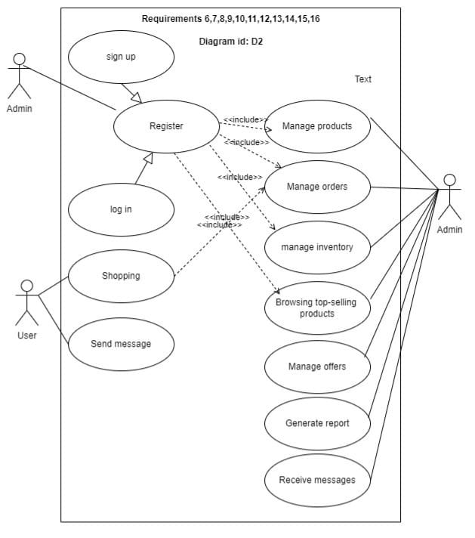

**Use Case 1: Manage order**

**1. Requirement number:** R2

**2. Use Case Diagram:** D2

**3. Primary Actor:** User/Admin.

**4. Trigger**: Admin wants to manage order ordered by the user.

**5. Preconditions:**

* The user has already ordered.
* The admin has already arranged ordered into different classes so he can manage them.

**6. Main Flow:**

* Admin receive the order.
* Admin check the order and see if it is valid or not.
* If yes, confirm and sign the order and see it in the stock.
* Admin wait to deliver the goods.
* Admin send to the user to send advance payment.
* Deliver the products.
* User(customer) receive the order.

**7. Alternative Flow:**

* **Scenario 1:** User want to change/remove something in his order after he confirm the order .
* **Scenario 2:** User order is not a valid one:
  + System will send to him that the order isn't valid so he can change it .

**8. Postconditions:**

* The Admin will send the user what he order .

**Use Case 2: Manage inventory**

**1. Requirement number:** R3

**2. Use Case Diagram:** D2

**3. Primary Actor:** User/Admin.

**4. Trigger**: Admin wants to manage inventory.

**5. Preconditions:**

* The admin has already classified the items we get so if user enter he can choose what he want.

**6. Main Flow:**

* Admin manage the demand, supply, movement of items.
* Admin classified inventory process into 4 stages: raw material, work in progress, finished goods, and goods for resale.
  + Raw materials – materials and components scheduled for use in making a product.
  + Work in process, WIP – materials and components that have began their transformation to finished goods.
  + Finished goods – goods ready for sale to customers.
  + Goods for resale – returned goods that are salable.
* Admin manage that the first order ordered is the first order to be sent.

**7. Alternative Flow:**

* **Scenario 1:** Admin forget to change/remove the items out of fashion so it will be problem if the user choose it.

**8. Postconditions:**

* The User will receive the order .

**Use Case 3: Browsing Top-selling products**

**1. Requirement number:** R4

**2. Use Case Diagram:** D2

**3. Primary Actor:** User/Admin.

**4. Trigger**: Admin wants to know which items is the top selling products .

**5. Preconditions:**

* The admin has already manage the inventory of the items we get so he know now which item is the most selling one.

**6. Main Flow:**

* Admin try to search about the most trending items.
* The most trending items with the best prices
* After that he can classified them according to:
  + Trendy
  + Best price
  + Age of the people enter our website and they interests
  + Best look
* Then Admin will now know which one is top-selling products

**7. Alternative Flow:**

* **Scenario 1:** Admin can also make a poll so any user can say in his opinion which one is the best item and from that he can know the most selling one .

**8. Postconditions:**

* The Admin will put the most selling products in the top of the page .

**Use Case 4: Manage offers**

**1. Requirement number:** R5

**2. Use Case Diagram:** D2

**3. Primary Actor:** Admin.

**4. Trigger**: Admin wants to make some offers so customer would love to order .

**5. Preconditions:**

* The admin has already know which item is the most selling one, so the next step is trying to make offers on the items that is looking like it.

**6. Main Flow:**

* Admin get requests from email, telephone or data entry form integrated in your website.
* Then he generate an individual offer based on the request
* Admin send the offer to the company design as an email with PDF-file or URL.
* Then track all customer interactions in one place.
* Monitor users accounts and plan next steps and contacts.
* Track your customers’ feedback on your offers.

**7. Alternative Flow:**

* **Scenario 1:** Admin can also try underrated offers as a card goes with the first order whenever you order again you can buy with a discount 20%.

**8. Postconditions:**

* The Admin will increase the sells of the project

**Use Case 5: Generate report**

**1. Requirement number:** R6

**2. Use Case Diagram:** D2

**3. Primary Actor:** Admin.

**4. Trigger**: Admin will write a report to discuss in it how is the project .

**5. Preconditions:**

* The admin must collect information about the sells , offers done, inventory process, number of products the project have now.

**6. Main Flow:**

* Admin should collect the objective of the report
* figure out what User/Manager need to see
* get the information you need to make it
* collect data, diagram and images you will insert in it
* Review and edit your report

**7. Alternative Flow:**

* **Scenario 1:** Admin can't make a good report without insert all objective we need

**8. Postconditions:**

* The Admin will surronded by everything going with the project

**Use Case 6: Receive messages**

**1. Requirement number:** R7

**2. Use Case Diagram:** D2

**3. Primary Actor:** Admin.

**4. Trigger**: Admin will receive message from system .

**5. Preconditions:**

* The admin will get messages to tell him to continue the plan or not.

**6. Main Flow:**

* Admin will receive message from Manger/User
* He will read the contents in it and try to understand what is the thing that he need from him
* Then he will write a respond
* He will send the respond

**7. Alternative Flow:**

* **Scenario 1:** message may not reach the Admin because of a bad conditions , or Admin respond

**8. Postconditions:**

* The Admin will understand everything going on with his project

.